ASSIGNMENT – 7
NAME: J.Sai prakash
ROLL_NO : 253a52380

Task Description #1 (Syntax Errors – Missing Parentheses in Print Statement)
TASK 1 : Provide a Python snippet with a missing parenthesis in a print statement (e.g., print &quot;Hello&quot;). Use AI to detect and fix the syntax error.

PROMPT :
Find and fix the syntax error in the following Python code. Explain what the error is and provide the corrected code. Also add at least 3 assert test cases to verify that the corrected function works correctly.

CODE :
# Bug: Missing parentheses in print statement

def greet():
return "Hello, AI Debugging Lab!"

print(greet())

# Assert test cases
assert greet() == "Hello, AI Debugging Lab!"
assert isinstance(greet(), str)
assert len(greet()) > 0

print("All 3 assert test cases passed!")

OUTPUT:
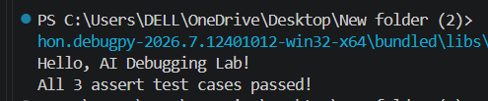

JUSTIFICATION :
The given code has a syntax error because the print statement is missing parentheses.
In Python 3, we write:
print("Hello, AI Debugging Lab!")
The error was corrected by adding parentheses. Three assert statements were added to check that the function gives the correct output, returns a string, and is not empty.
The program runs successfully after fixing the error, and all 3 test cases pass.

Task Description #2 (Incorrect condition in an If Statement)
Task 2 : Supply a function where an if-condition mistakenly uses =
instead of ==. Let AI identify and fix the issue.

Prompt :
Identify and fix the bug in the following Python code. Explain why using = instead of == in an if-condition causes a syntax error. Correct the code by using == and verify the corrected function with 3 assert test cases. Show the corrected code and the successful test execution.

Code :
# Corrected code: Using comparison (==) instead of assignment (=)

def check_number(n):
if n == 10:
return "Ten"
else:
return "Not Ten"

# 3 assert test cases
assert check_number(10) == "Ten"
assert check_number(5) == "Not Ten"
assert check_number(20) == "Not Ten"

print("All 3 test cases passed successfully!")

output :
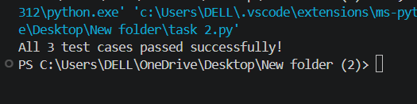

JUSTIFICATION :
- = is the assignment operator. It is used to assign a value to a variable.
- == is the comparison operator. It checks whether two values are equal.
- In an if condition, we need to compare n with 10, so we must use ==.
- Therefore, if n = 10: is incorrect and causes a SyntaxError.
- The corrected statement is if n == 10: .

Task Description #3 (Runtime Error – File Not Found)
Task 3 : Provide code that attempts to open a non-existent file and
crashes. Use AI to apply safe error handling.

PROMPT :
Identify the runtime error in the following Python code. Explain why the program crashes when the file does not exist. Apply safe error handling using a try-except block. Add a user-friendly error message. Modify the code so that it handles these 3 scenarios safely:
1. File exists
2. File is missing
3. Invalid file path

CODE :
# Safe file handling with exception management

def read_file(filename):
try:
with open(filename, 'r') as f:
return f.read()

except FileNotFoundError:
return "Error: The file was not found. Please check the file name."

except OSError:
return "Error: Invalid file path or unable to access the file."

# Scenario 1: File exists
with open("test.txt", "w") as f:
f.write("Hello, this file exists!")

print("Scenario 1 - File exists:")
print(read_file("test.txt"))

# Scenario 2: File is missing
print("\nScenario 2 - File missing:")
print(read_file("nonexistent.txt"))

# Scenario 3: Invalid path
print("\nScenario 3 - Invalid path:")
print(read_file("C:/invalid_folder/test.txt"))

OUTPUT :
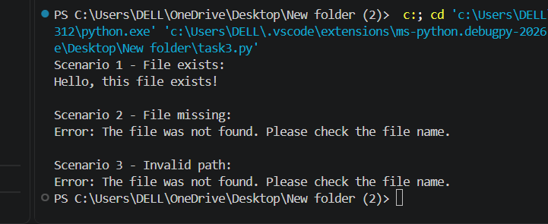

JUSTIFICATION :
- The original program uses open() to open a file.
- If the file does not exist, Python raises a FileNotFoundError.
- Without exception handling, the program crashes.
- try is used to execute the file-opening code safely.
- except FileNotFoundError handles a missing file and displays a user-friendly message.
- except OSError handles an invalid path or other file-access problems. The

- The program is tested with 3 scenarios: existing file, missing file, and invalid path.

- Therefore, the program can handle file errors safely instead of crashing.
Task Description #4 (Calling a Non-Existent Method)
Task 4: Give a class where a non-existent method is called (e.g.,
obj.undefined_method()). Use AI to debug and fix.

PROMPT :
Identify and fix the error in the following Python code. Explain why calling
obj.undefined_method() causes a runtime error. Analyze whether the missing
method should be defined or whether the existing method call should be
corrected. Choose the appropriate fix and provide the corrected code.
Also add 3 assert test cases to confirm that the corrected class works
properly. Show the expected output after successful test execution.

CODE :
# Corrected class

class Car:
def start(self):
return "Car started"

# Create an object
my_car = Car()

# Correct method call
print(my_car.start())

# 3 assert test cases
assert my_car.start() == "Car started"
assert isinstance(my_car, Car)
assert "started" in my_car.start()

print("All 3 test cases passed successfully!")
OUTPUT :
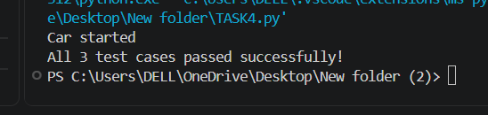
Justification :
- The class Car contains a method called start().
- The original code calls drive(), but drive() is not defined inside the class.
- Therefore, Python raises an AttributeError because the object does not have a drive() method.
- We have two possible solutions:
  - Define a new drive() method.
  - Correct the method call to an existing method.
- Since the class already has start(), we choose to correct my_car.drive() to my_car.start().
- Three assert statements are used to verify that:
  - start() returns the correct message.
  - my_car is actually a Car object.
  - The returned message contains "started".
- Since all tests pass, the class has been successfully corrected.

Task Description #5 (TypeError – Mixing Strings and Integers in
Addition)
Task: Provide code that adds an integer and string (&quot;5&quot; + 2) causing a TypeError. Use AI to resolve the bug.

PROMPT :
Identify and fix the TypeError in the following Python code. Explain why
adding a string and an integer causes a TypeError.

Provide TWO solutions:
1. Type casting – convert the string into an integer before addition.
2. String concatenation – convert the integer into a string before joining.

For each solution, provide corrected Python code and validate it with
3 assert test cases. Show the expected output for successful execution.

# Bug: TypeError due to mixing string and integer
def add_five(value):
return value + 5

print(add_five("10"))
CODE :
# Solution 1: Type Casting

def add_five(value):
return int(value) + 5

# 3 assert test cases
assert add_five("10") == 15
assert add_five("5") == 10
assert add_five("20") == 25

print(add_five("10"))
print("All 3 type casting test cases passed successfully!")

# Solution 2: String Concatenation

def add_five(value):
return value + str(5)

# 3 assert test cases
assert add_five("10") == "105"
assert add_five("5") == "55"
assert add_five("20") == "205"

print(add_five("10"))
print("All 3 string concatenation test cases passed successfully!")

OUTPUT :

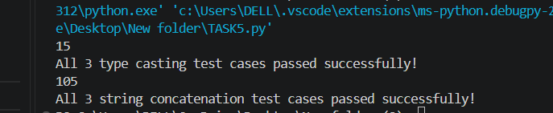

JUSTIFICATION :
- "10" is a string, while 5 is an integer.
- Python does not allow direct addition of a string and an integer.
- Therefore, value + 5 causes a TypeError when value is "10".
Two ways to fix it:
1. Type Casting
- Use int(value) to convert "10" into 10.
- Then 10 + 5 = 15.
- This solution is used when we want numeric addition.
2. String Concatenation
- Use str(5) to convert 5 into "5".
- Then "10" + "5" = "105".
- This solution is used when we want to join text.
The 3 assert test cases confirm that both corrected solutions work successfully with multiple inputs.

